Easy Job
Research Write up

Group Members:
Alish pandey
Gauri Shrestha
Jawad Zaman
Srijana Shrestha
Nirvika Poudel

Adv. Computer Programming - COM370-B01
Professor Eleni Zamagias
May 6, 2026

Introduction
There are several challenges regarding applying for and hiring, particularly within the STEM field. Some of these challenges arise from the amount of time spent applying to jobs and also the realistic expectations employers may have about their candidates, and the candidates may have about the employers (Baird, 2016). To address these modern-day problems, we have created a job-finding platform called Easy Job specifically designed for students in STEM. To better understand our expectations, we will look and compare two existing platforms: LinkedIn and Handshake.
Existing Application
LinkedIn
LinkedIn is a good benchmark for finding jobs because it has a large number of job postings in addition to other features like networking opportunities for users and recruiters to find talent via recruiting efforts. LinkedIn does very well in providing opportunities for networking among others, but when recruiting via LinkedIn, there may be a vast number of job postings, which can cause feelings of overwhelmingness for candidates (“AI in the Job Market,” 2025).
Handshake
Handshake is a better benchmark for students, especially because Handshake is very focused on connecting college students to employers in a more academic way. While there are great connections between college students and employers via Handshake, it lacks an ability to filter or sort job postings in an advanced manner (Uddin, 2025). Being university-level limits the opportunities to the broader network.
Comparison to Easy Job
STEM students often have questions regarding the recruitment process; therefore, the objective of Easy Job is to fill the gap between STEM students and employers and help them communicate their expectations of each other. Easy Job plans to overcome many of the shortcomings present on platforms such as Handshake and LinkedIn through a more targeted and user-centered platform. One of the main differences between Easy Job and other job search sites is its swipe-to-match feature, similar to that of other matchmaking apps, which allows a job seeker to quickly scan through jobs available on Easy Job and indicate whether they are interested in a job or not.
Unlike LinkedIn, where a job seeker can be overwhelmed with too many job listings to the point of being unable to make a decision, Easy Job will only show job seekers those jobs that match their skills, experience, and preferences. There are also filtering and sorting options available to job seekers on Easy Job, which allows them to customize their preferences and eliminate any jobs that they are not interested in, whereas LinkedIn’s general search feature provides limited ability to filter job listings. Job seekers and recruiters on Easy Job will have the ability to be connected to one another directly as soon as they indicate interest in each other, contrary to those using LinkedIn and Handshake, where both are limited in their ability to communicate with one another.

GUI Prototype
Below we have presented a GUI that features the elements to ensure easy navigation and usability:
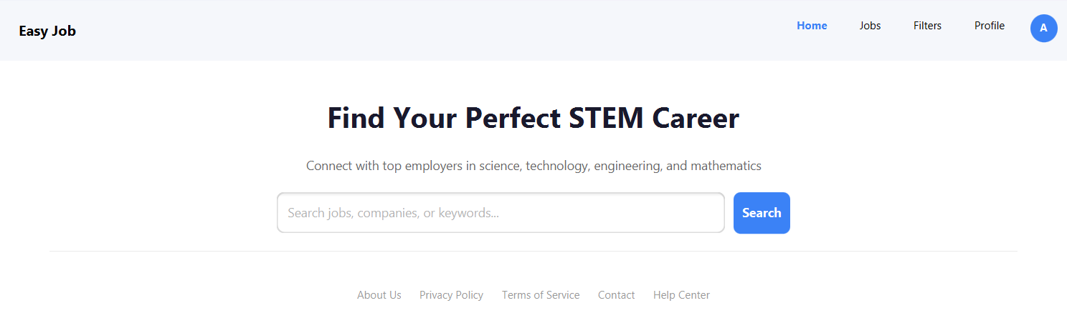
Figure 1: Home Page GUI
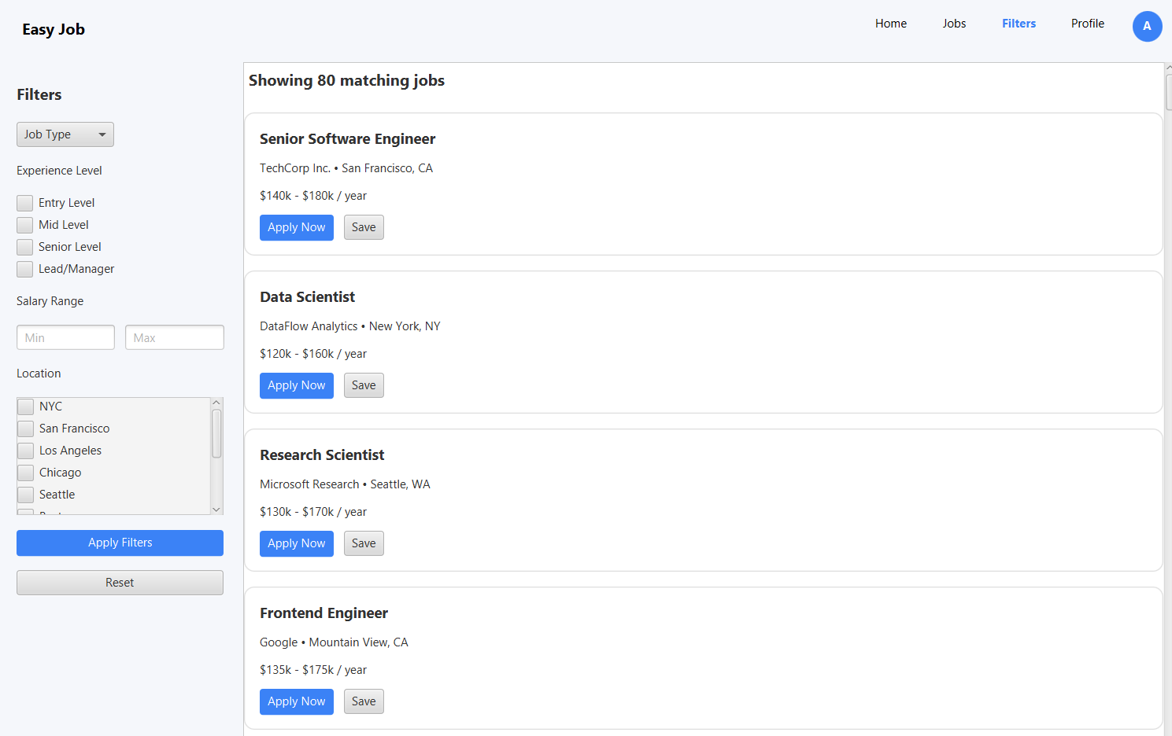
Figure 2: Job Listing Page GUI
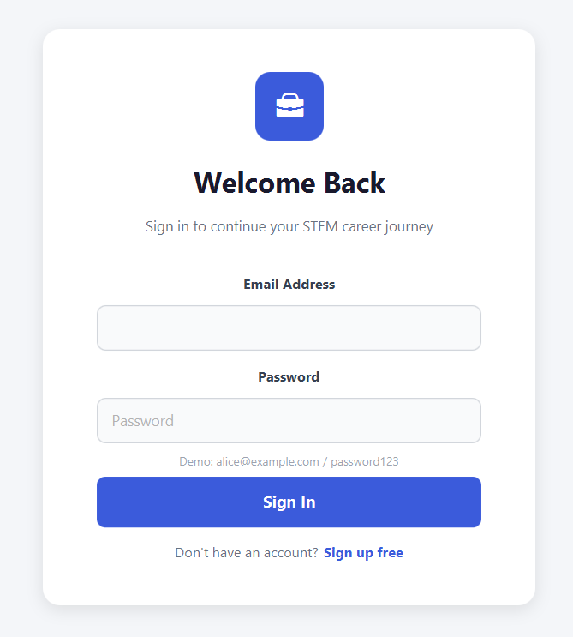
Figure 3: Login Page GUI
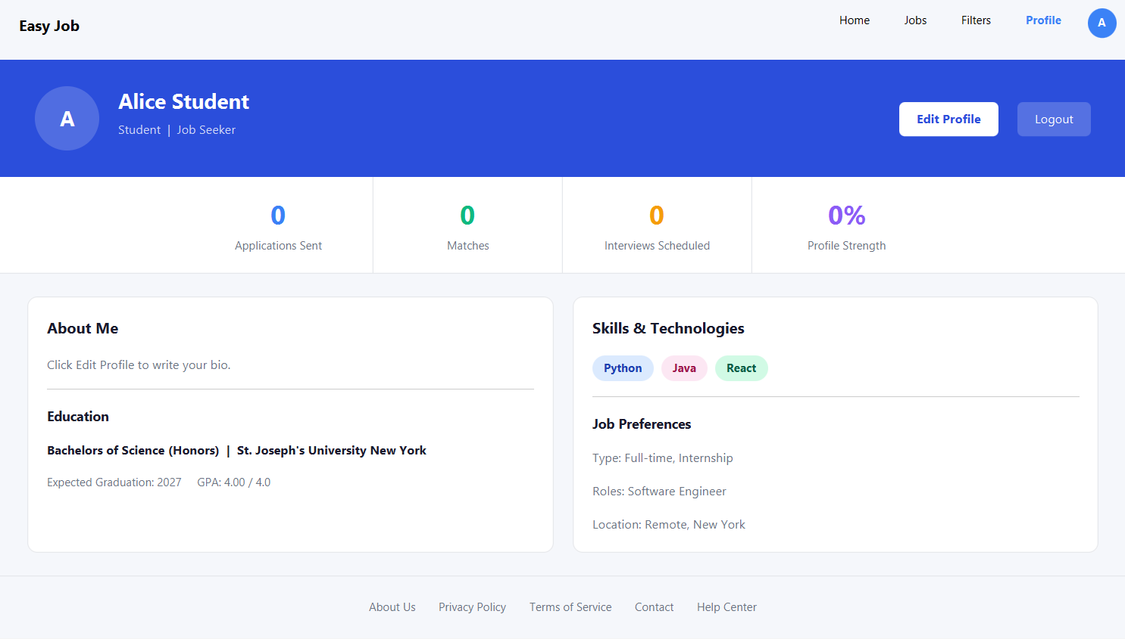
Figure 4: Profile Page GUI
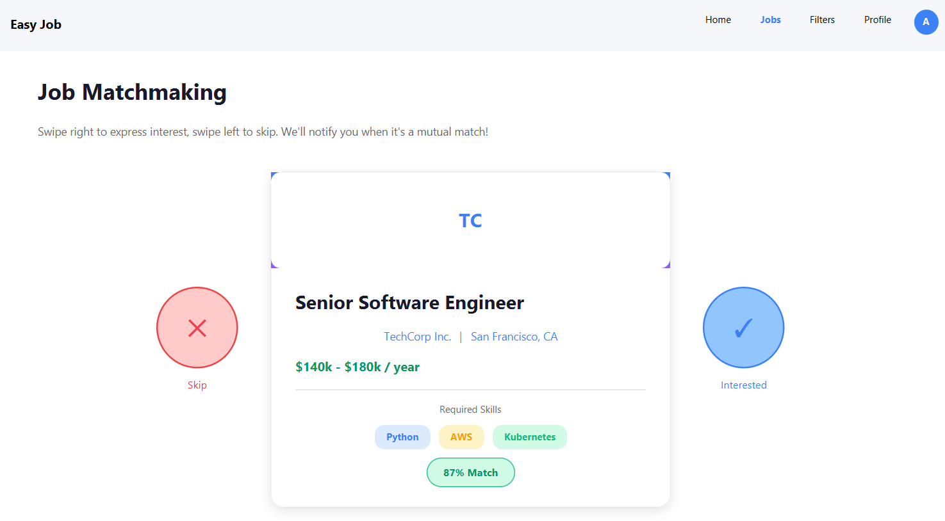
Figure 5: Job Matchmaking GUI
Event Flow Diagram
The event flow diagrams given below illustrate the flow of the action for Easy Job: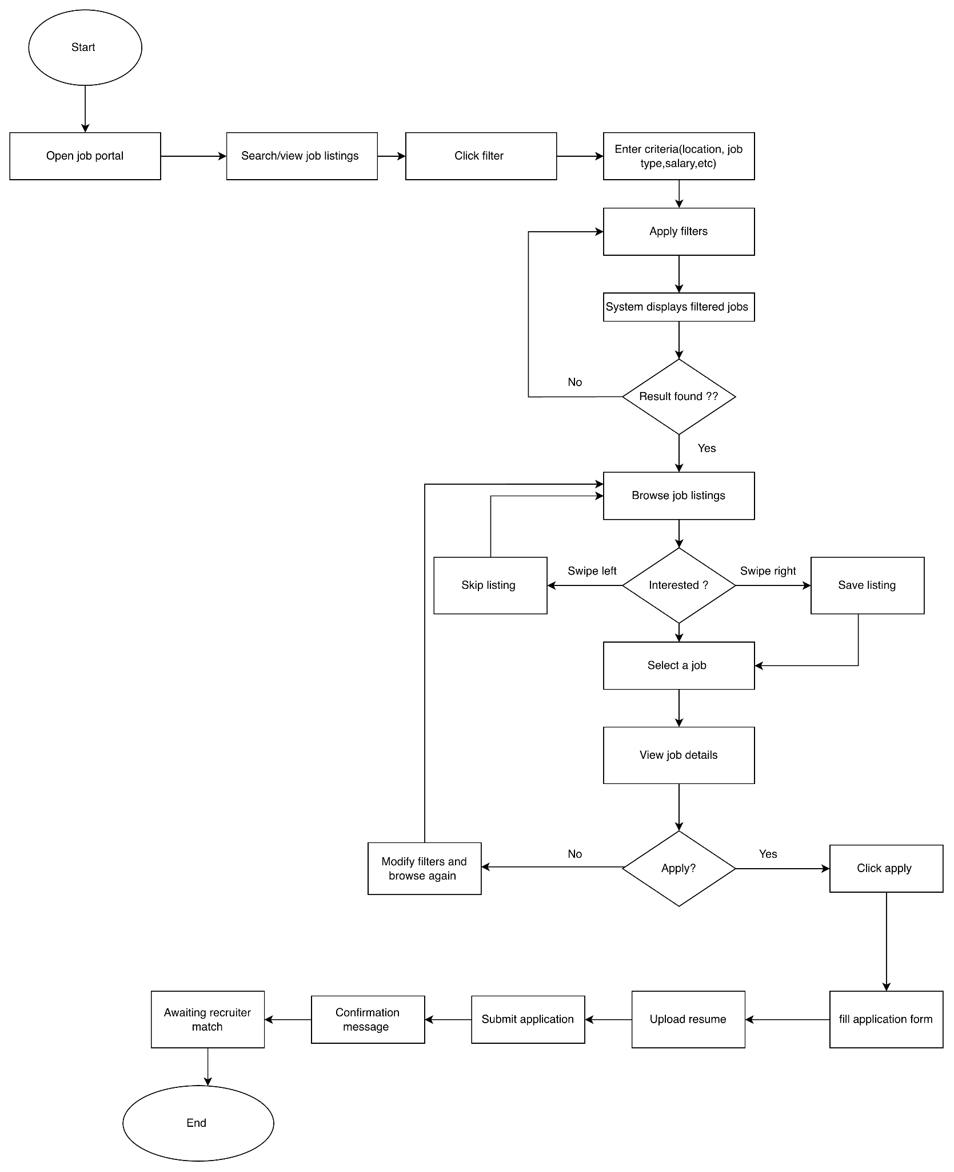
Figure 7: Information Loading and Matching Workflow
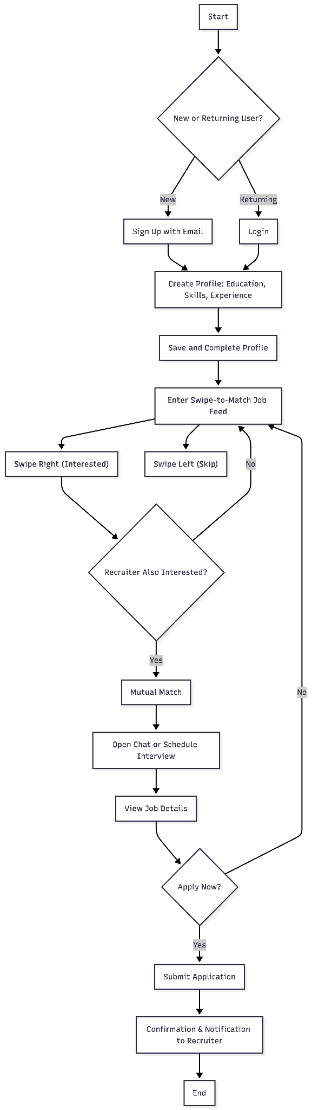
Figure 8: Login Workflow
Reflection
The purpose of this paper is to present the progress summary of what we have done so far regarding Easy Job’s platform, including how much user design or research we have done so far based on the user-centered design principles. The GUI prototype and event flow diagram represent our user-centered design in making the process of finding a job, specifically for those in STEM, as intuitive and efficient as possible. We will be using an open-to-close approach to develop these features in addition to using other functions and creating as seamless a process as possible through the users’ swipe’ ability to filter their results based on multiple criteria and communicate with employers directly. After developing several initial designs, we will be improving upon our designs and ultimately ensure that Easy Job will meet the needs of those currently looking for employment within the STEM field.

References
Baird, A. M. (2016). 21st Century Workforce: Employers’ Ratings of Importance and Satisfaction of Skills and Competencies College Graduates Need to Get Hired in the Northeast (Order No. 10250179). Available from ABI/INFORM Collection. (1864688791). https://ez.sjny.edu/login?url=https://www.proquest.com/dissertations-theses/21-sup-st-century-workforce-employers-ratings/docview/1864688791/se-2
AI in the Job Market. (2025). The Brian Lehrer show, https://ez.sjny.edu/login?url=https://www.proquest.com/trade-journals/ai-job-market/docview/3252288430/se-2
Uddin, R. (2025). Curiosity, confidence, and communication — how to apply for jobs online. FT.Com,
https://ez.sjny.edu/login?url=https://www.proquest.com/trade-journals/curiosity-confidence-communication-how-apply-jobs/docview/3228735865/se-2

